How to install angular4

1.Installation and configuration

npm install -g @angular/cli

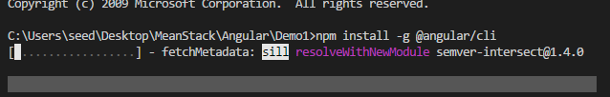

Angular CLI is command line tool to create project, run and build project

2. ng new my-app

